NCAA Men’s Basketball Database

ERD:

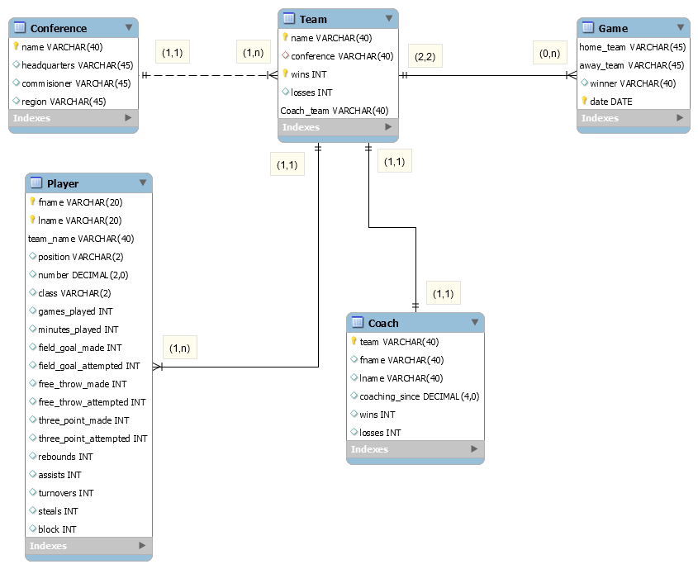

Relation Schema’s Reduced from ERD:

**Conference(name, headquarters, commissioner, region)**

**Team(name, conference, wins, losses, coach_team)**

Conference is an FK to conference relation

Coach_team is an FK to coach relation

**Player(fname, lname, team_name, position, number, class, games_played, minutes_played, field_goals_made, field_goals_attempted, free_throw_made, free_throw_attempted, rebounds, assists, turnovers, steals, block)**

Team_name is an FK to team relation

**Coach(team, fname, lname, coaching_since, wins, losses)**

Team is an FK to team relation

**Game(home_team, away_team, winner, date)**

Home_team is an FK to team relation

Away_team is an FK to team relation

Since there is no many-to-many relationships, there are no relation tables.

Every many-to-one and one-to-one relationships have FK’s.